GOOD FRIDAY SERVICE
HUNTERS RIDGE COMMUNITY CHURCH
FRIDAY, APRIL 7, 2023
PRELUDE MUSIC Pamela Houk
OPENING SCRIPTURE & PRAYER 1 Peter 2:24
HYMN “Here Is Love, Vast As The Ocean”

THE NARRATION OF PASSION WEEK

MONDAY
Jesus Curses the Fig Tree and Clears the Temple
Mark 11: 12-19

TUESDAY
Lessons From the Fig Tree, Scuffling with Religious Leaders and
Prophesy on the Mount of Olives
Mark 11: 20-24; Matthew 23:27, 28, 33; Matthew 24:3-5

CELEBRATION HYMNAL # 324 “When I Survey the Wondrous Cross”

WEDNESDAY
Jesus Teaches His Disciples and Religious Leaders Plot to Kill Jesus and Judas Desires to Betray Jesus
Matthew 26:1-16

CELEBRATION HYMNAL # 314 “What Wondrous Love Is This”

THURSDAY
Jesus Washes the Disciples’ Feet and The Last Supper
John 13: 1-15; Luke 22:15-20

WORSHIP SONG “We Hunger and Thirst”

THE LORD’S SUPPER

Jesus’ Agony in the Garden of Gethsemane and Judas Betrays Jesus
Luke 22:39-46; Matthew 26:47-56

HYMN “Stricken, Smitten and Afflicted”

THE FOCUS ON THE PASSION

FRIDAY
Crucifixion And Death
Matthew 26:69-75; Matthew 27:1-6

Period of Silence

Preparation for the Burial
John 19:39-42

MEDITATION - Pastor Howard Anderson Galatians 3:13
“Christ’s Curse – Our Gain”
CELEBRATION HYMNAL # 642 “Abide With Me”
CLOSING PRAYER

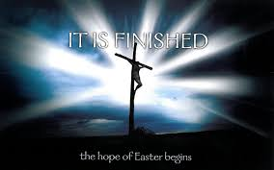
What Is So Good About Good Friday?
What is Good Friday and why do we call Good Friday “good,” when it is such a dark and bleak event commemorating a day of suffering and death for Jesus?
For Christians, Good Friday is a crucial day of the year because it celebrates what we believe to be the most momentous weekend in the history of the world. Ever since Jesus died and was raised, Christians have proclaimed the cross and resurrection of Jesus to be the decisive turning point for all creation. Paul considered it to be “of first importance” that Jesus died for our sins, was buried, and was raised to life on the third day, all in accordance with what God had promised all along in the Scriptures 1 Corinthians 15:3.
On Good Friday we remember the day Jesus willingly suffered and died by crucifixion as the ultimate sacrifice for our sins 1 John 1:10. It is followed by Easter, the glorious celebration of the day Jesus was raised from the dead, heralding his victory over sin and death and pointing ahead to a future resurrection for all who are united to him by faith Romans 6:5.
Still, why call the day of Jesus’ death “Good Friday” instead of “Bad Friday” or something similar? Some Christian traditions do take this approach: in German, for example, the day is called Karfreitag, or “Sorrowful Friday.” In English, in fact, the origin of the term “Good” is debated: some believe it developed from an older name, “God’s Friday.” Regardless of the origin, the name Good Friday is entirely appropriate because the suffering and death of Jesus, as terrible as it was, marked the dramatic culmination of God’s plan to save his people from their sins.
In order for the good news of the gospel to have meaning for us, we first have to understand the bad news of our condition as sinful people under condemnation. The good news of deliverance only makes sense once we see how we are enslaved. Another way of saying this is that it is important to understand and distinguish between law and gospel in Scripture. We need the law first to show us how hopeless our condition is; then the gospel of Jesus’ grace comes and brings us relief and salvation.
In the same way, Good Friday is “good” because as terrible as that day was, it had to happen for us to receive the joy of Easter. The wrath of God against sin had to be poured out on Jesus, the perfect sacrificial substitute, in order for forgiveness and salvation to be poured out to the nations. Without that awful day of suffering, sorrow, and shed blood at the cross, God could not be both “just and the justifier” of those who trust in Jesus Romans 3:26. Paradoxically, the day that seemed to be the greatest triumph of evil was actually the deathblow in God’s gloriously good plan to redeem the world from bondage.
The cross is where we see the convergence of great suffering and God’s forgiveness. Psalms 85:10 sings of a day when “righteousness and peace” will “kiss each other.” The cross of Jesus is where that occurred, where God’s demands, his righteousness, coincided with his mercy. We receive divine forgiveness, mercy, and peace because Jesus willingly took our divine punishment, the result of God’s righteousness against sin. “For the joy set before him” Hebrews 12:2 Jesus endured the cross on Good Friday, knowing it led to his resurrection, our salvation, and the beginning of God’s reign of righteousness and peace.
Good Friday marks the day when wrath and mercy met at the cross. That’s why Good Friday is so dark and so Good.
Justin Holcomb https://www.christianity.com/god/jesus-christ/what-s-so-good-about-good-friday.html
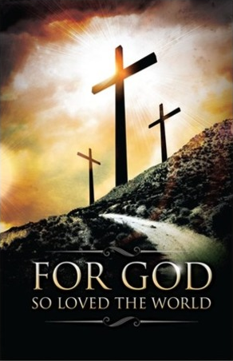
Hunters Ridge Community Church
A North American Baptist Conference Church
850 School Road SW, Hutchinson, MN 55350-2147
e-mail:hrccpastorh@gmail.com or hrccsec@gmail.com
website: huntersridgecommunitychurch.org (320) 587-8374

